**National Virtual Village Gathering**

**& In-Person Conference with WAVE**

**Virtual: October 3-4, 2023**

**In-Person: October 17, 2023**

**(in Silver Spring, Maryland)**

**SPONSOR PROSPECTUS**

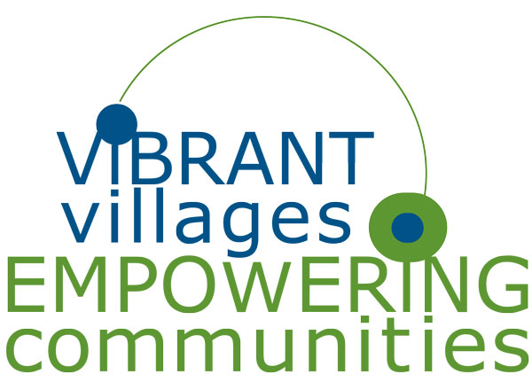

**About VtV Network**

VtVN is the national association that champions Villages as a cost-effective, sustainable model for healthy, vibrant aging. Through its programs, services and resources, VtVN empowers Villages in formation, energizes functioning Villages and serves as a Village commons to connect its members.

The Network also advocates for the Village Movement at the local, state and national levels. VtVN membership has more than tripled since our founding in 2009.

Several hundred Villages are enabling more than 40,000 older adults to continue living at home in a safe, healthy and socially connected way. VtVN members are currently in 42 states, the District of Columbia and three countries (U.S., Canada and Australia).

258

Operating

Villages

55

Developing

Villages

3

Countries

U.S., Australia, Canada

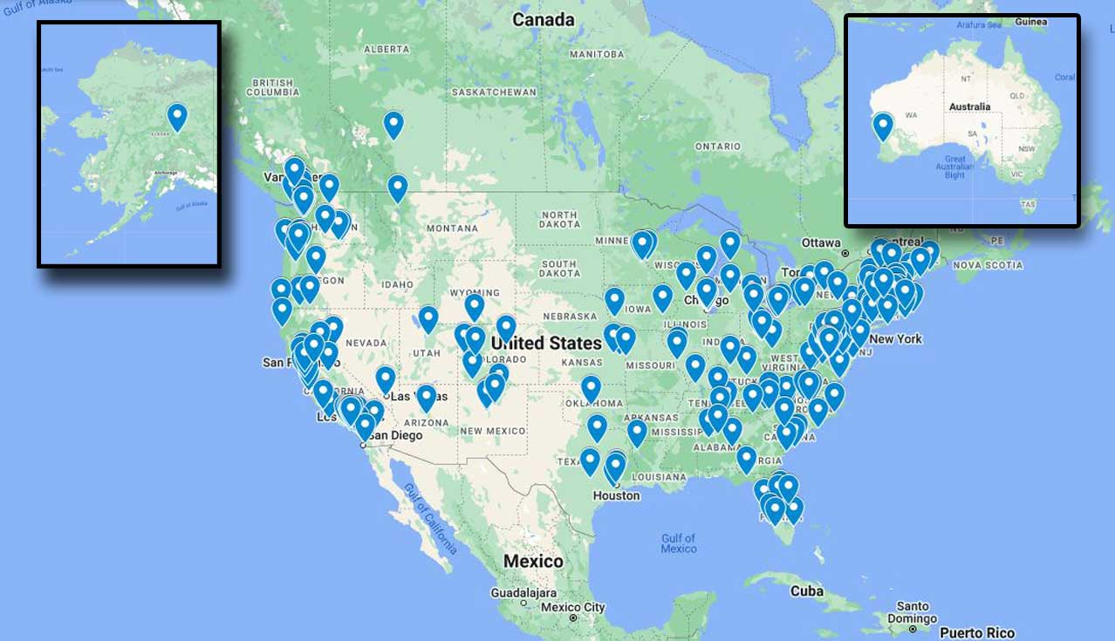

40,000+

Older Adults

Served

**Sponsorship Levels**

|  |  |  |  |  |
| --- | --- | --- | --- | --- |
|  | Bronze | Silver | Gold | Platinum |
|  | **$500** | **$1,250** | **$3,500** | **$7,500** |
| Conference Sponsor Listing on Website | ● | ● | ● | ● |
| Social Media |  | ● | ● | ● |
| 5 minute Sponsor Spotlight (Virtual) |  | ● |  |  |
| Webinar (TBD) | ● | ● | ● | ● |
| FREE Registration for both conferences | **X1** | **X2** | **X2** | **X4** |
| 60 min. Workshop |  |  | ● |  |
| 60 min. Plenary at  Virtual or In-Person Conference |  |  |  | ● |
| Exhibitor @ Civic Center: Oct. 17 | **Additional $500** | **Additional $250** | **Included** | **Included** |

**Benefit Breakdown**

**Conference Sponsor Listing on Website:** Sponsors will be featured on the Village to Village Network website until next year’s conference.

**Social Media:** VtVN will share links to your website from our social media platforms before and after the conference.

**5 minute Sponsor Spotlight:** During the conference, Sponsor will have 5 minutes to talk about your product or service.

**Webinar (TBD):** Sponsor will have the opportunity to present to VtVN’s membership on a mutually agreeable date and time.

**FREE Registration:** Sponsors will receive the number of registrations listed for free.

**Speaker/Presenter:** Sponsors will have time to present, based on sponsorship level.

**Exhibitor @ Civic Center:** Get face-to-face interaction with Village leaders on Oct. 17 in Silver Spring Maryland.

**About NVVG 2023**

**SPONSORS:**

Sponsorship at the National Village Conference is an excellent opportunity to position your brand at the forefront of Village leaders and supporters who represent more than 40,000 older adults across the country and abroad. The National Virtual Village Gathering will focus on both learning and networking. This annual gathering provides a unique opportunity to reach potential customers. You will also support the mission and be a part of the Village movement, promoting the success of all older adults.

**WHO ATTENDS:**

Village to Village Network member Villages, Staff, Board Members, Volunteers, Individual Village Members, those interested in topics on aging and industry experts. Attendees also include caregivers, social workers, nurses, geriatricians, aging in place specialists, local government officials and researchers.

**Past Sponsors**









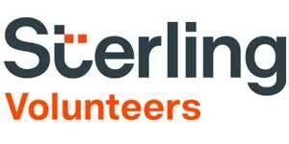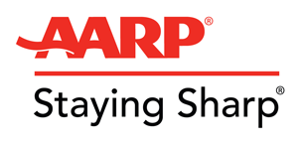

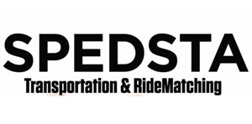

**Sponsor Agreement**

Please complete the following agreement and either mail or email it to Village to Village Network Executive Director, Barbara Sullivan (PO Box 2041 Ventnor City, NJ 08406 or vtv@vtvnetwork.org).

Agreement Deadline – May 1, 2023

***Please select the sponsorship opportunity you would like from the list below:***

**Sponsorship Level:**

Bronze **………………………………………………. $500 (**optional +$500 for exhibitor space**)**

Silver **………………………………………………… $1,250 (**optional +$250 for exhibitor space**)**

Gold **………………………………………………….. $3,500**

Platinum **……………………………………………… $7,500**

**Payment**

**Village to Village Network will send an invoice upon receipt of signed Sponsor Agreement.**

**Sponsor Information**

By signing below you agree to complete your payment by July 15, 2023.

Sponsorships are non-refundable.

For payment questions, please email vtv@vtvnetwork.org or call 617.299.9638.

Name: Click or tap here to enter text. Title: Click or tap here to enter text.

Organization: Click or tap here to enter text.

Address: Click or tap here to enter text.

Email: Click or tap here to enter text. Phone: Click or tap here to enter text.

Website: Click or tap here to enter text. Social Media: Click or tap here to enter text.

Signature: Click or tap here to enter text. Date: Click or tap here to enter text.

Names of Additional Attendees: Click or tap here to enter text.

Logo: 

**Deadlines and Dates to Remember**

**Agreement Deadline: May 1, 2023**

**Payment By: July 15, 2023**

**NVVG 2023: October 3-4, 2023**

**In-Person Conference: October 17, 2023**

**Questions?**

For more information or questions please contact the Village to Village Network:

**Call: 617-299-9638**

**Email:** **vtv@vtvnetwork.org**

**Visit: www.vtvnetwork.org**

